IR W7152 ½” Impact
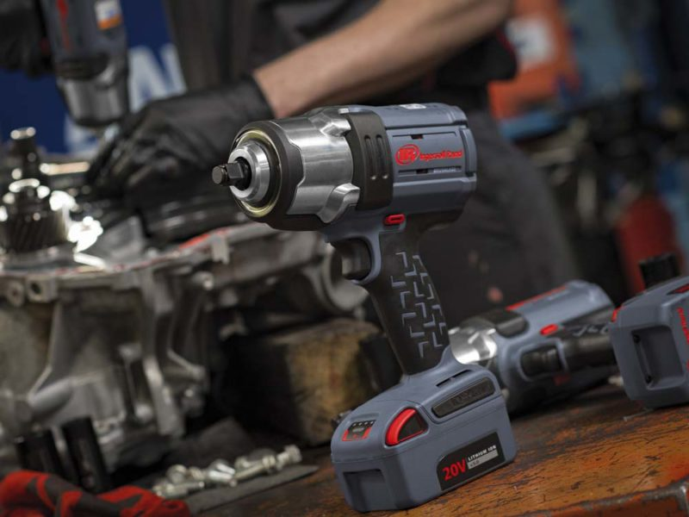

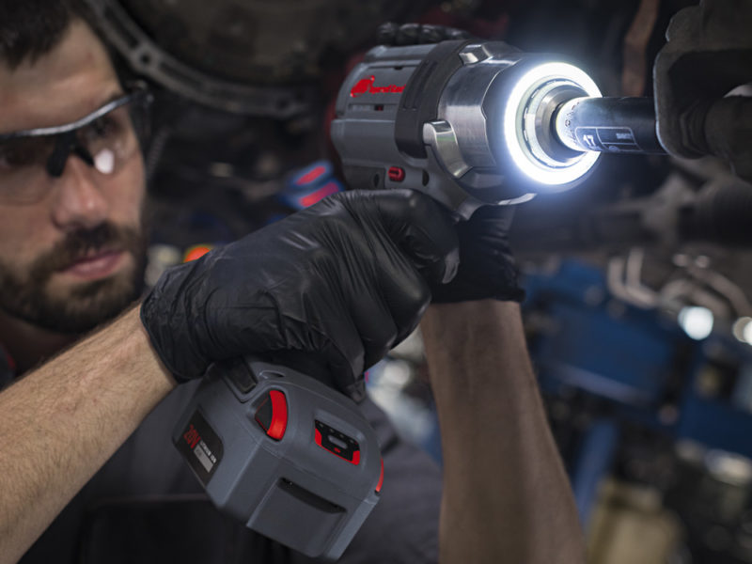

Ingersoll Rand W7152 IQv20 Features
As with the newer little brother, this new IR W7152 impact is built on the IQv20 platform. This is Ingersoll Rand’s intelligent power control system, operating on their 20V max batteries. With 20-volts lithium power and a brushless motor, this Ingersoll Rand W7152 is putting out 1,500 lb-ft of torque. These are huge claims, especially with a 1/2″ anvil – the highest in the industry. Delivering these gorilla-loads of power can wreak havoc on internal components. The Ingersoll Rand W7152 includes an all-metal drivetrain and hammer mechanism.
In addition to the huge power output, Ingersoll Rand added 4 modes : Max power, Mid power, Wrench tight, and Hand tight. These modes aren’t controlled by any illuminated buttons, this is a big red dial on the back of the impact. It’s no mistake which mode you’re in because it’s staring you right in the face. A variable speed trigger allows the user even further control of the power output.

Ergonomics are Not Forgotten
At only 8.1″ from the anvil to the tail, this is one of the most compact impact wrenches in its class. Furthermore, this new Ingersoll Rand W7152 weighs in at only 7.6 lbs. This size and weight, or lack thereof, should be a big asset to most mechanics. Ingersoll Rand continues to use their impact and chemical resistant housings and overmolds that provide ergonomic comfort as well.

Light Up Your Life – Or Work Area
A shadowless LED light ring surrounds the anvil 360-degrees. This puts the light exactly where you need it – on your work. The LED light ring can even be used as a task or work light as well. There are four dimmable settings, and the user can control time settings as well.

Ingersoll Rand W7152 IQv20 Modes
- Hand Tight Mode
  - Speed: 600 RPM
  - Tightening Torque: 4-10 ft-lbs
  - Shut-off: Yes
- Wrench Tight Mode
  - Speed: 1000 RPM
  - Torque: 35-110 ft-lbs
  - Shut-off: Yes
- Mid Power Mode
  - Speed: 0-1450 RPM
  - Tightening Torque: 530 ft-lbs
  - Shut-off: No
- Max Power Mode
  - Speed: 0-1900 RPM
  - Tightening Torque: 1000 ft-lbs
  - Shut-off: No

Ingersoll Rand W7152 Specifications
- Model: W7152
- Voltage: 20-volt Max (18V Nominal)
- Anvil: 1/2″ Retaining Ring
- Impacts Per Minute: 2450
- Max Tightening Torque: 1000 ft-lbs
- Nut-Busting Torque: 1500 ft-lbs
- No-Load Speed: 0-1900 RPM
- Weight (Tool & Battery): 7.6 lbs
- Length Tip to Tail: 8.1″
- MSRP
  - W7152: $515 (Bare Tool)
  - W7152-K12: $732 (1 – 5.0Ah Battery, Charger, and tool bag)
  - W7152-K22: $832 (2 – 5.0Ah Batteries, Charger, and tool bag)
- Release Date: September 2018

